**ICT SEMESTER PROJECT (PHASE:02)**

**Group Members**

* **Sarim Ali , Roll no : 232466**
* **Sheikh Abdul Hadi Mehmood , Roll No : 233038**
* **Class :- BSCS-ev-C**

**General introduction to the website**

First of all, the name of our website is FITNESS SYMMETRY. As we know that our health is our most valuable wealth. A person’s physical fitness measures health and fitness. By considering this, hope our website will be helpful to the user’s who are health and fitness conscious.

**Task#03 : Project Requirements**

* **Workout Programs**: Display different workout programs focusing on symmetry, targeting various muscle groups.
* **Exercise Demonstrations**: Provide videos or images demonstrating exercises that promote symmetry in the body.
* **Progress Tracking**: Implement tools for users to track their fitness progress and symmetry improvements.
* **User Accounts**: Allow users to create accounts, customize profiles, and save favorite workouts or progress data.
* **Search and Filter Options**: Enable users to easily find specific workouts based on muscle groups, difficulty levels, etc.
* **Accessibility**: Design with accessibility standards in mind, ensuring the website is usable for all users, including those with disabilities.
* **Responsive Support**: Include contact information or chat support for user inquiries or issues.
* **Responsive Design**: Ensure the website looks good and functions well across various devices (desktops, tablets, mobile phones).
* **Clean and Intuitive Interface**: Design a user-friendly interface with easy navigation and clear calls-to-action.

**Task#04 : User story of our website’s Front End**

As our website’s front end seems like this :

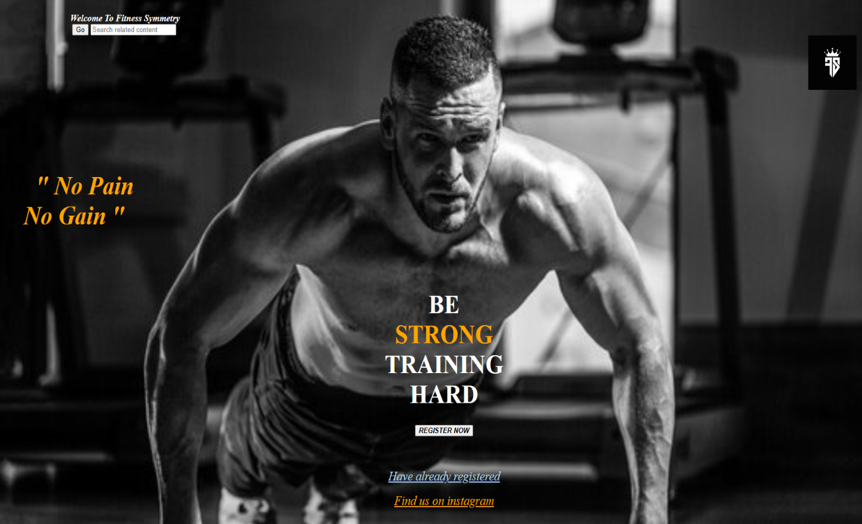

* A person who will be health conscious might find our website, in order to make his body fit and free from diseases.
* As a user, first I will visit the website FITNESS SYMMETRY.
* Secondly, if I am conscious about my fitness, I’ll go forward.
* Then as a user I will first register on fitness symmetry by clicking on the button register now.
* By clicking on the button register now, I will reach a type of form in which I will be able to put my information(Name,height,weight,phone number etc.) .
* After putting my information I will be registered on this website & after that I will become a member of fitness club and a diet plan and a exercise plan will be given to me according to the information that I have entered on the form i.e name,height,weight etc.
* Similarly, if I am already registered on this website, I will simply click on the button “Have already registered” and I will reach to my personal diet & exercise plan according to my height,weight etc. previously entered in the form.
* If I am worried about my diet or any other thing, I can simply search that thing in the search bar given on the left top.
* Moreover, if I think that I wanna need a coach or a trainer who will guide me, I can visit the website’s Instagram page and contact them.
* Furthermore, on the website’s Instagram page contact’s of the trainers are posted or mentioned and I can easily tell them which problem or difficulty I am facing regarding to my diet and exercise plan.